Basic Network Sniffer Assignment Report

Overview
A network sniffer is a cybersecurity tool used to monitor and capture data packets that travel across a computer network. These packets contain information such as source and destination IP addresses, protocol used, and communication details between devices.
This assignment demonstrates how a basic network sniffer can be built using Python and the Scapy library to capture and analyze live network traffic.

Tools and Technologies used
- Python (Programming Language)
- Scapy (For packet sniffing and analysis)
- Npcap (Windows packet capture driver)
- Jupyter Notebook
- PowerShell terminal

Methodology
The project was implemented using Python and Scapy. The steps followed were:
- Install Scapy using Scapy
- Install Npcap for packet capturing support on Windows
- Write a Python script to sniff packets
- Run the script in the terminal
- Observe and analyze live network traffic

Picture
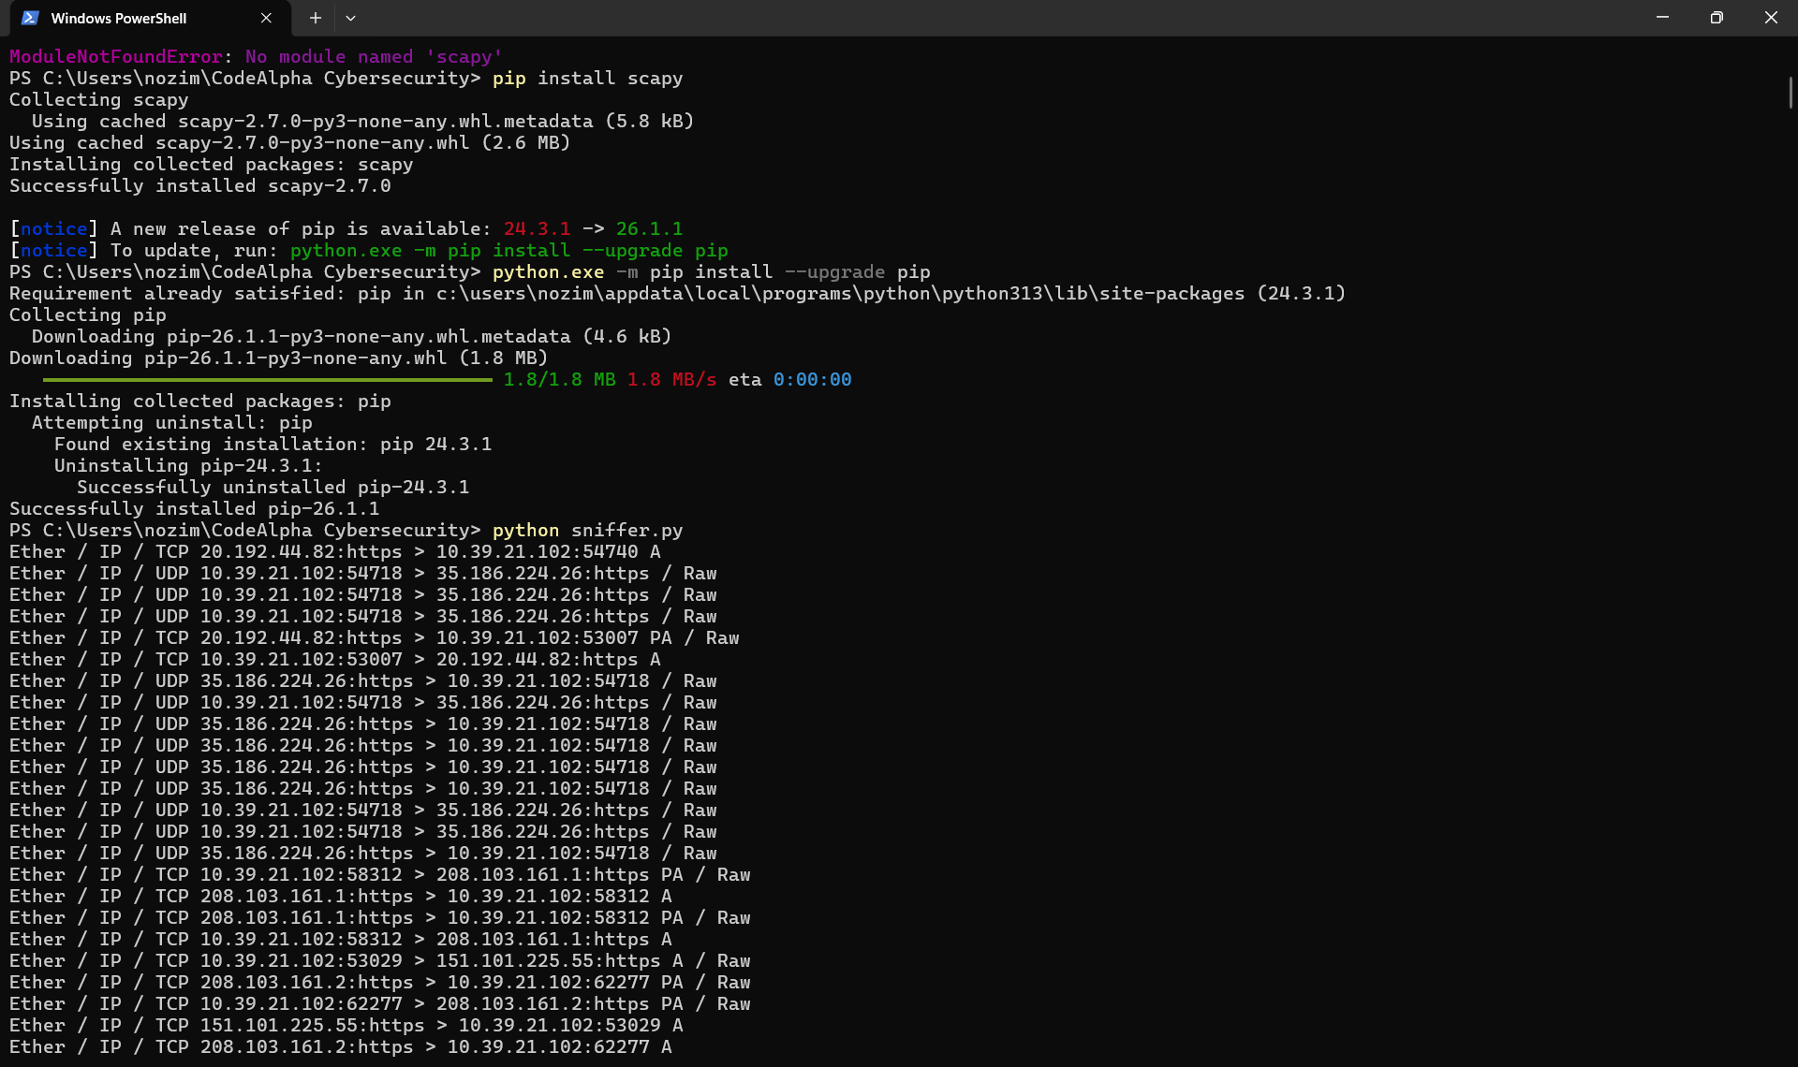
Figure 1: Sniffer running on PowerShell Terminal

Challenges Faced
- Missing Scapy module initially (resolved using pip installation)
- Windows required Npcap installation for packet capture
- File format confusion between .ipynb and .py
- Directory issues when running the script from terminal

Conclusion
This assignment successfully demonstrated the implementation of a basic network sniffer using Python. The tool was able to capture and display live network packets, providing insight into how devices communicate over a network.

